Little Dribblers Registration Form
(Detach this portion & return by 12/02/2016.)

Name of camper: ____________________________________

Grade: K 1 2 3 4

Shirt size (youth): S M L
(8 -9) (10 -12) (14 – 16)

Shirt size (adult): S M L XL

Emergency Contact: _________________________________

Emergency Phone #: _________________________________

My child and I agree to abide by the following rules:
- Follow safety rules and other instructions provided by the activity instructors and coaches.
- Share responsibility for my personal safety and not endanger others who are participating in the activity.
- Immediately report all defective equipment and/or unsafe acts and dangerous conditions to the Camp Coach or Camp Staff.
- I acknowledge by attending the activity my child is encouraged to have a physical examination in advance and obtain adequate personal health and accident insurance prior to participating in the activity.
- In case of emergency, accident or illness, I give my permission for my child to be treated by a professional medical person and admitted to the hospital if necessary. I agree to be responsible for all medical expenses which are incurred.
I acknowledge that my child is participating at his own risk. I understand that there is a risk of injury in participating in Little Dribblers, due to the inherent nature of the activity. By signing below, I acknowledge that I understand this assumption of risk, agree to the conditions listed above, and will not hold the school, Glencoe Youth Basketball or camp personnel liable.

Parent/Guardian Signature___________________________

Date___________

Parent/Guardian Contact email address: _____________________________________________
(Email used to communicate camp updates.)

Please return completed registration to:

Glencoe High School
C/O Josh McInnis
2700 NW Glencoe Road
Hillsboro, OR 97124-1518

Make Checks payable to:

Glencoe Youth Basketball

LITTLE DRIBBLERS
2017

Who: Open to boys and girls in the Glencoe area who are in grades K thru 4.

When: Every Saturday: 8:30-10:30 AM. Starting: January 7th.
Ending: February 25th.

Where: Alternate weekly between Free Orchards Elementary and Patterson Elementary.

What: All athletes will receive instruction on the fundamentals of basketball and incorporate new found skills into fun games.

Cost: $35*. All campers will receive a camp shirt.

* Campers costs go to cover the camper’s shirt and camp related expenses. Camp staff is 100% volunteer.

Head Coaches

Jeremy Stewart and Jeff Eischen will head the program for Little Dribblers and live in the Glencoe area. Both have many years of experience playing and coaching. They are committed to providing a welcoming atmosphere for young athletes to enjoy and learn the game of basketball. Jeremy has 3 kids, and his eldest is a 1st grader. Jeff has 6 kids, and his eldest is in 4th grade.

Assistant Coaches

High school coaches ranging from the head coach to assistant coaches will be in attendance through out the duration of this program. High school athletes from both programs will also be in attendance helping provide instruction and demonstrating drills and techniques.

ROLL TIDE!!

Why Little Dribblers for your child?

1. Gain early access to the game of basketball.
It is our mission to teach kids age appropriate skills that are anchored around the game of basketball, within a safe and positive environment.

2. FUN!
The game of basketball is fun for both the players and the coaches. We love teaching the game!

3. Connect with other kids from the Glencoe elementary schools.
We have such a great community around Glencoe, and this is an early opportunity for campers and parents to connect with each other across the Glencoe community.

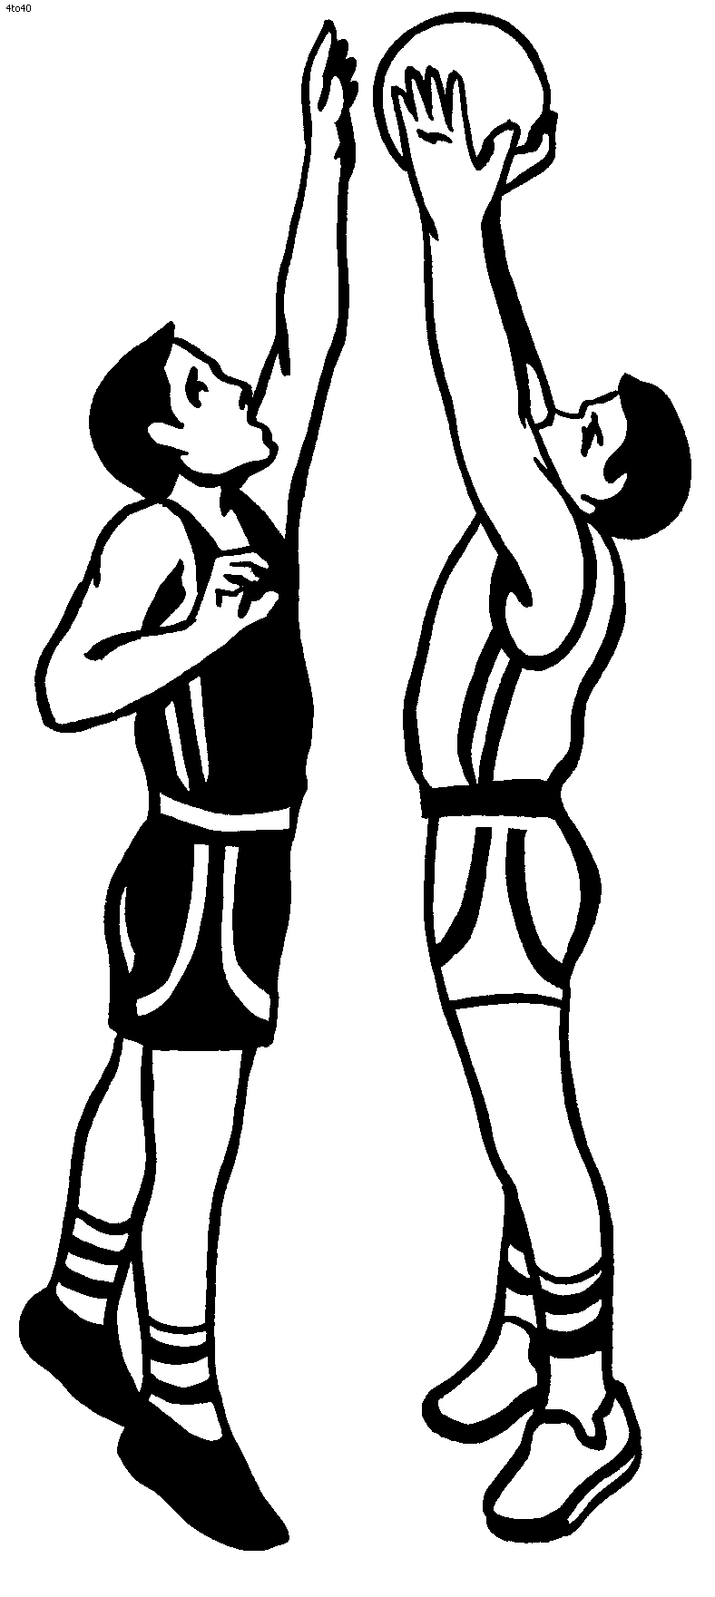

Calling Volunteer Coaches

If you have a passion to help our youth learn new skills that translate to a healthy life and the concept of both personal and team success, we could use your help.

Positive attitude, good work ethic, and great with kids is required.

Basketball coaching experience optional*.

Please contact Jeremy Stewart: jeremyfstewart@hotmail.com.

* Head coaches will provide detailed instruction and practice plans to all coaches.

